Setup FastAPI

- Run this commad :
- python -m venv myenv
- myenv/Scripts/activate
- pip install fastapi uvicorn pyd
- Run App :
- uvicorn filename:app_object(app) –reload
Ex. Uvicorn app:app –reload

from fastapi import FastAPI

app = FastAPI()

@app.get('/') - Handles GET requests to fetch the welcome message from the root endpoint.
def index():
return {"message": "Welcome to Sarkar API"}

@app.post ('/demo') - Handles POST requests to receive and process new data at the /demo endpoint.
@app.put ('/predict') - Handles PUT requests to update prediction-related data or functionality.
@app.delete ('/profile') - Handles DELETE requests to remove profile-related data or resources.

# this line use to return Json respond
from fastapi.responses import JSONResponse

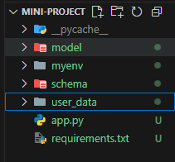
- Normal Architecture :
- Schema - pydantic models (data validation)
- User_data – data which is required to use like list
Dropdown options
- Model – train model (predict.py , model.pkl)

- For best practice use this type of Architecture for ML model with FastAPI:

fastapi-ml-app-folder/
│
├── app/
│ ├── __init__.py
│ ├── main.py # FastAPI app instance
│ ├── api/ # All API routes
│ │ ├── __init__.py
│ │ ├── predict.py # /predict route logic
│ │ └── health.py # /health, /status, etc.
│ ├── core/ # Core configs and startup logic
│ │ └── config.py
│ ├── models/ # Pydantic request/response schemas
│ │ ├── __init__.py
│ │ └── predict_schema.py
│ ├── services/ # Business logic and ML inference
│ │ └── model_service.py
│ ├── ml/ # Trained model and preprocessing pipeline
│ │ ├── model.pkl
│ │ └── transformer.pkl
│ └── utils/ # Utility functions/helpers
│ └── preprocess.py
│
├── requirements.txt
├── README.md
└── run.sh / run.py # App start script

Write command to run app in run.sh :
then open the git bash and activate myenv - source myenv/Scripts/activate
- ./run.sh

Path parameter : A path parameter in FastAPI is a dynamic part of the URL path that is used to capture a value directly from the URL itself. It acts like a placeholder in the URL and allows your API endpoint to accept variable values in the path.
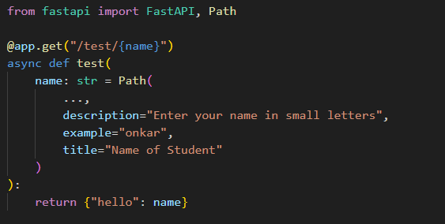

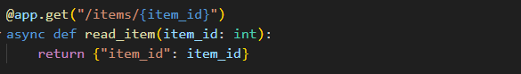

- Query Parameter : A query parameter is passed after the ? in the URL and is typically used for filtering, sorting, searching, or optional data .
Query in URL : /search_student?name=onkar
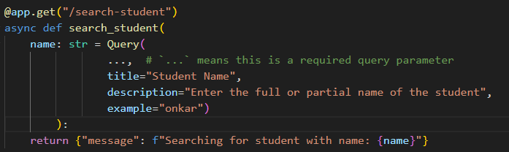

- Note : In Query , if you replace (…) with another value then it is default value.)
Ex. name : str = Query(“Guest”,description=””,title=””,example=””)

Pydantic :
from pydantic import BaseModel,EmailStr,AnyUrl,Field , field_validator,
model_validator
from typing import List,Dict , Optional , Annotated

- Field Validation : field_validator is used in FastAPI (with Pydantic ) to check and control the value of a single field in a data model before it's accepted — like making sure age isn't negative or a name is in lowercase.
# field_validator - used to costomize the validation
class Patient(BaseModel):
name:Annotated[str,Field(max_length=30 ,title="this is
name",description="this is name field",examples=["onkar"])]
age:int
marride:Annotated[bool,Field(default=None,description="patient is
married or not status")]
list_data:List[str]
dict_data:Dict[str,str]
email:Annotated[EmailStr,Field(max_length=40 , title="put your mail",
description="enter the valid mail",examples=["temp@gamil.com"])]
linkedin_url:AnyUrl

# customized our email for bussiness company for free services
@field_validator('email')
@classmethod
def email_validator(cls,value):
diff_domain = ['hdfc.com','icici.com']
domain_name = value.split('@')[-1]
if domain_name not in diff_domain:
raise ValueError("invalid domain name")
return value

- Model Validation : model_validator is used to validate or customize the entire data model after all fields have been processed.
@model_validator(mode="after") # after/before mode - customize
model(anything you can customize)
def custom_validation(cls,model):
if (model.age>60 and 'emergency' not in model.dict_data):
raise ValueError("Patient age is greater than 60 the
emergency contact is required")
return model

- Computed Field : A computed field is a field in a Pydantic model that is not passed by the user but is calculated automatically based on other fields.
# it is use calculate some value using existing field
@computed_field
@property
def BMI(self) -> float:
bmi = round(self.weight/(self.height**2),2)
return bmi

- Nested Model :
from pydantic import BaseModel

class Address(BaseModel):
street: str
city: str
state: str
zip_code: int

class Patient(BaseModel) :
name:str
age:int
address : Address

def set_user(user:Patient):
print(user.name)
print(user.age)
print(user.address)

